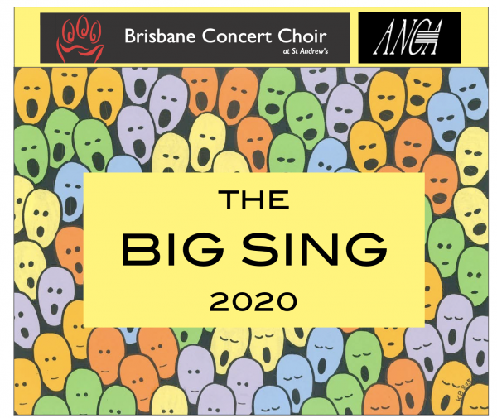

ANCA Big Sing 2020 Hosted by Brisbane Concert Choir

Friday 2 October to Sunday 4 October 2020
Coorparoo State High, Brisbane
Musical Director - Dr Debra Shearer-Dirié

REGISTRATION FORM

To register for ANCA Big Sing 2020 please complete this registration form and return it to Brisbane Concert Choir using any of the Contact Details listed below. Please complete your payment when you return this form in order to secure your registration.

REGISTRATION COSTS

- ANCA Members: $TBD
- Non-ANCA Members: $TBD
- Saturday Evening Dinner: $TBD (Limited to 120 people)

Please note that registration is not final until full payment has been made.

REGISTRATION DETAILS – CHOIRS ONLY
If you are registering multiple singers on behalf of a choir, please provide your contact details below.

Choir Name | Name
ANCA No (if relevant) | ANCA No
Your First Name | First Name
Your Last Name | Last Name
Address | Street 1  Street 2  City/Town  State Postcode
Phone | 555 5555
Email | singer@choir.com

Please list individual attendee’s names and details on the sheet below.

Registration as part of an ANCA member choir is charged at the member’s rate.

REGISTRATION DETAILS – INDIVIDUALS ONLY
If you are registering as an individual singer (whether or not you are affiliated with a choir) please provide your details below:

First Name | First Name
Last Name | Last Name
ANCA Membership No | ANCA No
Address | Street 1  Street 2  City/Town  State Postcode
Phone | 555 5555
Email | singer@choir.com
Voice Type | Soprano 1  Soprano 2  Alto  Tenor  Bass

PAYMENT
Please fill in the table below to indicate what you are paying for:

Item | Number  Of Singers | Cost | Total $
ANCA Member Full Registration |  | $TBD
Non Member Full Registration |  | $TBD
Dinner |  | $TBD
TOTAL

Payment Methods

- Direct Deposit
Account Name: Australian National Choral Assoc. QLD Branch
BSB No: 484-799
Account No: 024383095

- Cheque

To be made out to ‘Australian National Choral Assoc. QLD Branch’.
Post to:
Brisbane Concert Choir
9/60 Gubberley St
Kenmore
Qld 4069

OUR CONTACT DETAILS
E-MAIL
choir@brisbaneconcertchoir.com.au
SNAIL MAIL

Brisbane Concert Choir
9/60 Gubberley St
Kenmore
Qld 4069

PHONE
0475 262 649

SPECIAL CONSIDERATIONS

Diet
Please specify if there are any particular dietary requirements you wish caterers to be aware of regarding yourself, or your choir members.

List any dietary requirements here…

Access
Please specify if there are any particular access concerns you have, or would like to discuss with us so we can make arrangements for your, or your choir member’s needs.

List any accessibility requirements here…

Other Comments
Please specify if there are other issues, concerns or questions that you or your choir members may have in relation to the Big Sing.

List any additional comments requirements here…

Terms
All fees must be paid in full for registration to be accepted by us.

If you have registered for Big Sing 2020 and are unable to attend, you may send another person to attend in your place provided you inform Brisbane Concert Choir of the change not less than 72 hours prior to the event.

To cancel a registration for Big Sing 2020, contact us at the addresses under Our Contact Details, above. Full refund can only be provided if notice is received at least 30 days prior to the event. If cancellations are received up to 1 week prior to the event, a 50% refund is available. Refunds won’t apply to any cancellations received less than 1 week before the event.

OFFICE USE ONLY | Payment Received: dd/mm/2020  Processed By:

CHOIR NAME - LIST OF ATTENDEES

 | First Name | Last Name | Voice | Saturday Dinner?
1 | First Name | Last Name | ☐S1 ☐S2 ☐A ☐T ☐B | Y/N
2 | First Name | Last Name | ☐S1 ☐S2 ☐A ☐T ☐B | Y/N
3 | First Name | Last Name | ☐S1 ☐S2 ☐A ☐T ☐B | Y/N
4 | First Name | Last Name | ☐S1 ☐S2 ☐A ☐T ☐B | Y/N
5 | First Name | Last Name | ☐S1 ☐S2 ☐A ☐T ☐B | Y/N
6 | First Name | Last Name | ☐S1 ☐S2 ☐A ☐T ☐B | Y/N
7 | First Name | Last Name | ☐S1 ☐S2 ☐A ☐T ☐B | Y/N
8 | First Name | Last Name | ☐S1 ☐S2 ☐A ☐T ☐B | Y/N
9 | First Name | Last Name | ☐S1 ☐S2 ☐A ☐T ☐B | Y/N
10 | First Name | Last Name | ☐S1 ☐S2 ☐A ☐T ☐B | Y/N
11 | First Name | Last Name | ☐S1 ☐S2 ☐A ☐T ☐B | Y/N
12 | First Name | Last Name | ☐S1 ☐S2 ☐A ☐T ☐B | Y/N
13 | First Name | Last Name | ☐S1 ☐S2 ☐A ☐T ☐B | Y/N
14 | First Name | Last Name | ☐S1 ☐S2 ☐A ☐T ☐B | Y/N
15 | First Name | Last Name | ☐S1 ☐S2 ☐A ☐T ☐B | Y/N
16 | First Name | Last Name | ☐S1 ☐S2 ☐A ☐T ☐B | Y/N
17 | First Name | Last Name | ☐S1 ☐S2 ☐A ☐T ☐B | Y/N
18 | First Name | Last Name | ☐S1 ☐S2 ☐A ☐T ☐B | Y/N
19 | First Name | Last Name | ☐S1 ☐S2 ☐A ☐T ☐B | Y/N
20 | First Name | Last Name | ☐S1 ☐S2 ☐A ☐T ☐B | Y/N
21 | First Name | Last Name | ☐S1 ☐S2 ☐A ☐T ☐B | Y/N
22 | First Name | Last Name | ☐S1 ☐S2 ☐A ☐T ☐B | Y/N
23 | First Name | Last Name | ☐S1 ☐S2 ☐A ☐T ☐B | Y/N
24 | First Name | Last Name | ☐S1 ☐S2 ☐A ☐T ☐B | Y/N
25 | First Name | Last Name | ☐S1 ☐S2 ☐A ☐T ☐B | Y/N
26 | First Name | Last Name | ☐S1 ☐S2 ☐A ☐T ☐B | Y/N
27 | First Name | Last Name | ☐S1 ☐S2 ☐A ☐T ☐B | Y/N
28 | First Name | Last Name | ☐S1 ☐S2 ☐A ☐T ☐B | Y/N

